Exercise 2: E-commerce Platform Search Function

package sorting_algorithms;
public class Product {
int productId;
String productName;
String category;
public Product (int productId,String productName,String category){
this.productId=productId;
this.productName=productName;
this.category=category;

}
@Override
public String toString() {
return "[ProductId: "+productId+","+"ProductName: "+productName+","+" Category: "+category+"]";
}
}
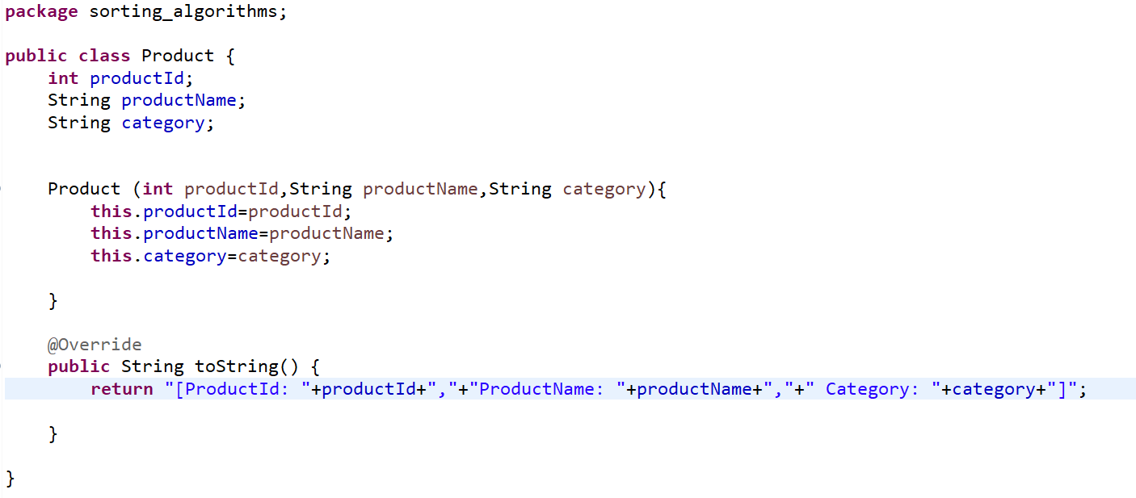

package sorting_algorithms;

public class LinearSearch {
public static Product linearSearch(Product[] product,int targetId) {
for(Product p:product) {
if(p.productId==targetId) {
return p;
}
}
return null;
}
}
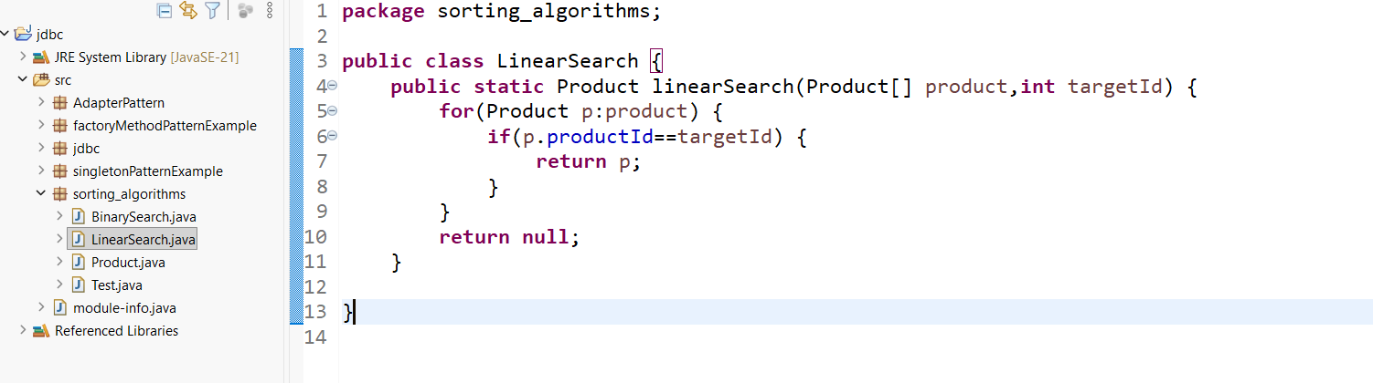

package sorting_algorithms;

public class BinarySearch {
public static Product binarySearch(Product[] products,int targetId) {
int low=0;
int high=products.length-1;
while(low<=high) {
int mid=(low+high)/2;
if(products[mid].productId==targetId) {
return products[mid];
}
else if(products[mid].productId<targetId) {
low=mid+1;
}
else
high=mid-1;
}
return null;
}
}
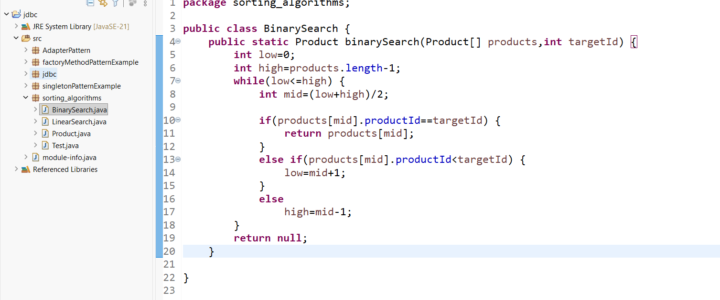

package sorting_algorithms;

public class Test {
public static void main(String[] args) {
Product[] products= {
new Product(101,"Laptop","Electronics"),
new Product(102, "Phone", "Electronics"),
new Product(103, "Shoes", "Fashion"),
new Product(104, "Watch", "Accessories"),
new Product(105, "Bag", "Fashion")
};
Product result1=LinearSearch.linearSearch(products,104);
System.out.println("Linear Search:"+result1);

Product result2=BinarySearch.binarySearch(products, 104);
System.out.println("Binary Search:"+result2);
}
}
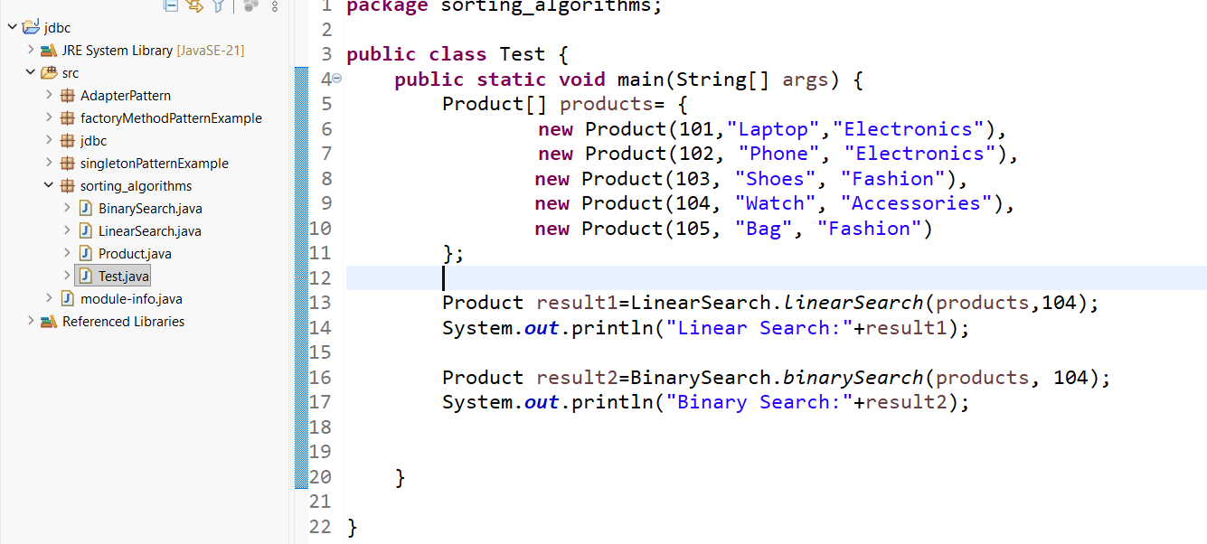
Output:
